Case 13-US-MA-Revere Beach-Pipe-Platform-

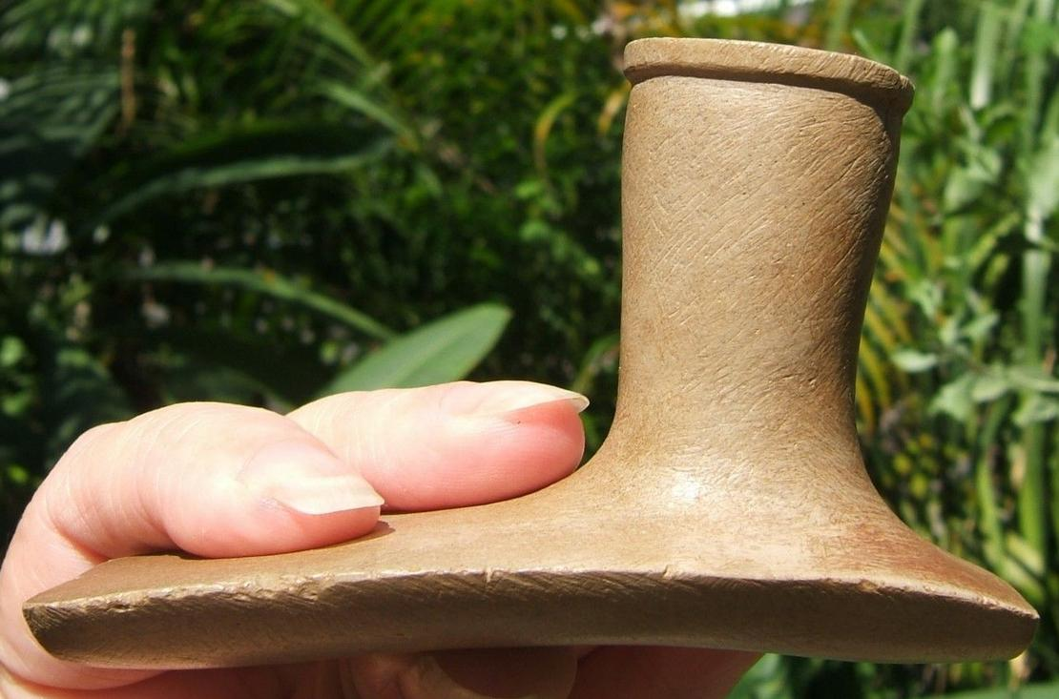

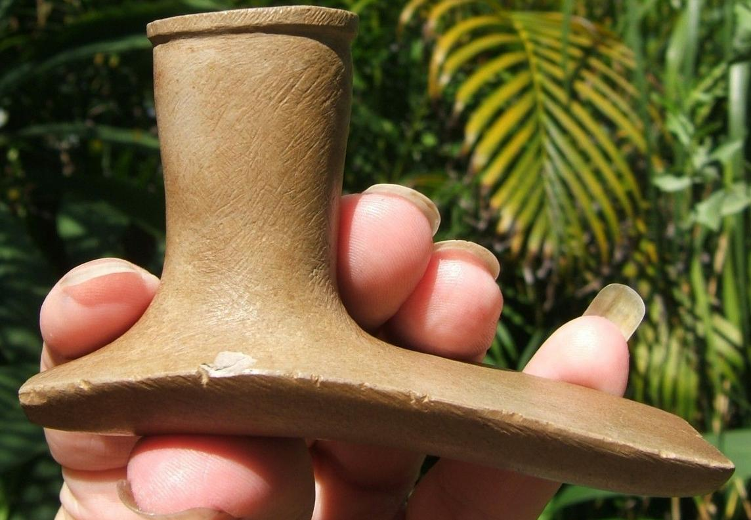

The circulation and accumulation of exotic materials in massive mortuary caches peaked during the Hopewell era (100 B.C. to A.D. 300). The premise that Hopewell smoking pipes were made in Ohio, primarily of local raw material, and circulated to foreign locations was an integral part of this interaction model. In this study we demonstrate, primarily using reflectance near-infrared spectroscopy (NIS), that early Hopewell Tremper Mound pipe raw-material acquisition focused on exotic pipestones from Illinois and Minnesota. By contrast, later Mound City cache pipes were almost exclusively made from local limestone and pipestone. The discovery of this shift in preference for and/or access to different quarry sources by Ohio Hopewell societies provides new perspectives on early Hopewell development and long-distance interaction.

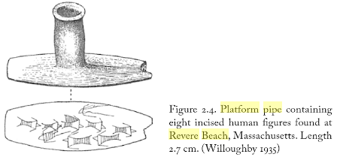



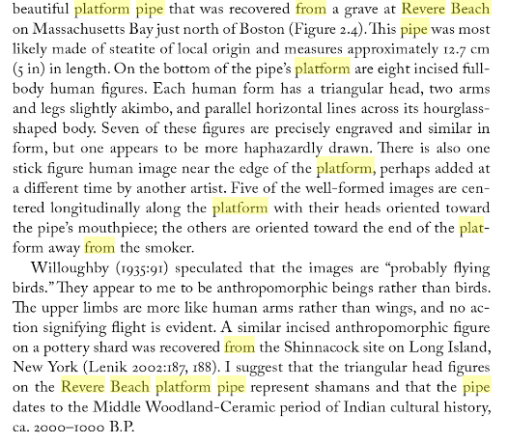

it is probable that pipe making stone cutters of this age were migrants from the west and not racial descendants from former occupants of the area. The new comers probably intermixed with the indigenous people and continued a few of their local traits in modified form, although they evidently abandoned most of them in favor of new ones that they brought with them.

Bullen, Ripley P. 1947. Three Beverly Graves. *Massachusetts Archaeol. Soc. Bull*, 8, No.2, pp. 22-24.

Fowler, W.S., 1951. Pipes and rare products of the stone bowl industry. *Massachusetts Archaeol. Soc. Bull.*, *13*, pp.13-20.

Hadlock, W.S., 1947. Eight platform or" monitor" pipes in the Peabody Museum, Salem, Massachusetts. *Massachusetts Archae-ological Society Bulletin*, *8*(4), pp.49-52.

Lenik, E.J., 2016. *Amulets, Effigies, Fetishes, and Charms: Native American Artifacts and Spirit Stones from the Northeast*. University of Alabama Press.

Willoughby, C.C., 1935. *Antiquities of the New England Indians: With Notes on the Ancient Cultures of the Adjacent Territory* (Vol. 17). Ams PressInc.

|  |  |
| --- | --- |
| ORDER DATEApr 11, 2016 | ORDER TOTAL  US $425.00  Free shipping  **Order 3 3/4" Museum Quality Hopewell Platform Pipe** [Leave feedback - ORDER DATE Apr 11, 2016](http://feedback.ebay.com/ws/eBayISAPI.dll?LeaveFeedbackShow&useridto=lynnscollectibles&transactID=1506477204001&item=111947891960&_trksid=p2057872.m2749.l2665)[View order details](http://payments.ebay.com/ws/eBayISAPI.dll?ViewPaymentStatus&transId=1506477204001&itemid=111947891960&_trksid=p2057872.m2749.l2673) - ORDER DATE Apr 11, 2016  [More actions - ORDER DATE Apr 11, 2016](http://www.ebay.com/myb/PurchaseHistory) |

1 item sold by [lynnscollectibles](http://www.ebay.com/usr/lynnscollectibles?_trksid=p2057872.m2749.l2754)

|  |  |  |
| --- | --- | --- |
| [3 3/4" Museum Quality Hopewell Platform Pipe](http://www.ebay.com/itm/111947891960?_trksid=p2057872.m2749.l2649&ssPageName=STRK%3AMEBIDX%3AIT)  ( 111947891960 )  Delivered on Thu, Apr 14  Tracking number: [**Tracking number**9505514162116103228013](javascript:;)  [Add note](javascript:;) | ITEM PRICE:  US $425.00 |  |

# Hopewell platform pipe of Ohio pipestone, from Adams County, Ohio. Length: 3 ¾ in.; width: 1 ¾ in.; heigth: 2 in.

Estimate $700.00.